Big Room
Week Commencing 16th March 2020

Rota – Week 2

In addition to all Continuous Provision this week’s Activities are:

Art and Craft | Seasonal Cards
Construction | Foam Building Bricks
Malleable Materials | Playdough
Mark Making | Free Choice
Small World | 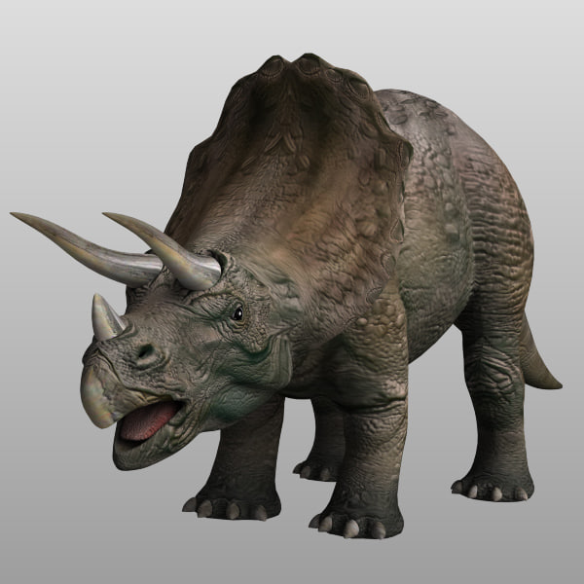  Dinosuar Island
Outside | Play house, sand pit, Bikes with ‘car wash
Big Room Table 1 | Magnets
Big Room Table 2 | Lego
Music and Movement | Dingle Dangle Scarecrow
Role Play | Home Corner, washing machine, cooker
Lunch Club Song | CD Player, story, song
Story | Free Choice
We shall be making seasonal cards this week for the children to take home at the end of the week. Our song of the week marks the beginning of spring (??). The children will be able to use their imaginations while playing with the dinosaur island.
Lunch Club
Lunch Club Song – CD Player, story, song
Book corner, Mark Making, Physical trolley, Foam Building Bricks, Dinosuar Island and Children’s requests

